# **Tasks**

**Objective Questions**:

1. **What is the total no. of tables present in the data?** The Raw Data Table and the Country Description Table are the two primary tables that contain the data. While the Country Description Table offers more contextual information about the countries, like country codes or basic country characteristics, the Raw Data Table contains the restaurant-specific information, including restaurant ID, name, address, cuisines, etc.
2. **What is the total no. of attributes present in the data?** Attributes are used in spreadsheets to label the data in each column. The dataset contains 20 attributes, each representing a distinct characteristic or piece of information about the restaurants. These attributes cover a wide range of restaurant details, such as the restaurant's location, type of cuisines, delivery options, customer ratings, and pricing information. This diversity in attributes allows for comprehensive analysis, from geographic and demographic factors to customer satisfaction and financial details.
3. **How many categorical columns are there in the data?**  
    The dataset includes 12 categorical columns, which contain non-numeric, qualitative data. These columns describe characteristics such as the name of the restaurant, location, city, address, locality, types of cuisines, and service options like whether the restaurant offers online delivery, has table booking, or delivers currently. These columns are essential for segmenting and grouping data for analysis.
4. **The data consists of some inconsistent and missing values so ensure that the data used for further analysis is cleaned.**a)There are some missing values in the Cuisine column, so we had to fill with the most common cuisine in that particular country.  
   b) There are format and spelling errors in the City column. We have to use find and replace.  
   c) Convert inconsistent date formats to a standard structure using the Date function. I converted the datekey_opening column in date format.  
   d) use another column to convert the Average_Cost_for_two column into INR and also I removed null values in that column.

This structured approach ensures clean, consistent, and reliable data for analysis.

1. **Using the LookUp functions, fill up the countries in the original data using the country code.** I have used the XLOOKUP function on column C of the cleaned data table to fill in the countries in the original dataset based on the country code. That is,  
     
   Combining the "CountryCode" from the Raw Data table with the matching country names in the "Country Description" field is a fantastic way to enhance the data. This guarantees that the right country is linked to each restaurant's entry.
2. **Create a table to represent the number of restaurants opened in each country.**  
    I have used a pivot table to effectively display the number of restaurants opened in each country. By placing "CountryCode" in the rows and counting the "Restaurant ID" in the values, one can easily visualize how many restaurants are located in each country. Large datasets can be summarized using this method, which also makes it easy to spot regional differences or patterns.  
    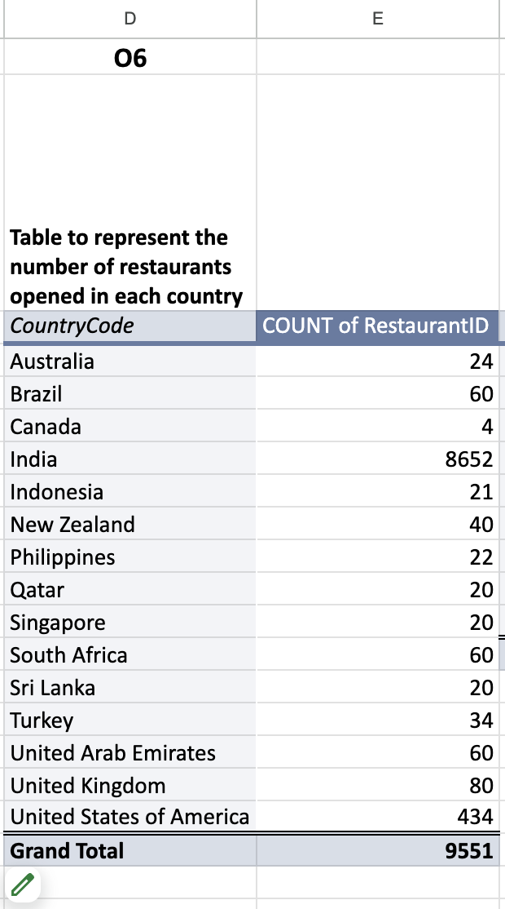
3. **Also, the management wants to look at the number of restaurants opened each year, so provide them with something here.** In the cleaned data table,I have created a column Year_opened, which extracts year only from Datekey_Opening column and inserted a pivot table to represent the number of restaurants opened each year.Taking Year_opened in rows and Count of Restaurant ID in values.  
   This pivot table showcasing the number of restaurants opened each year offers key insights into the growth pattern of Zomato’s restaurant network.  
    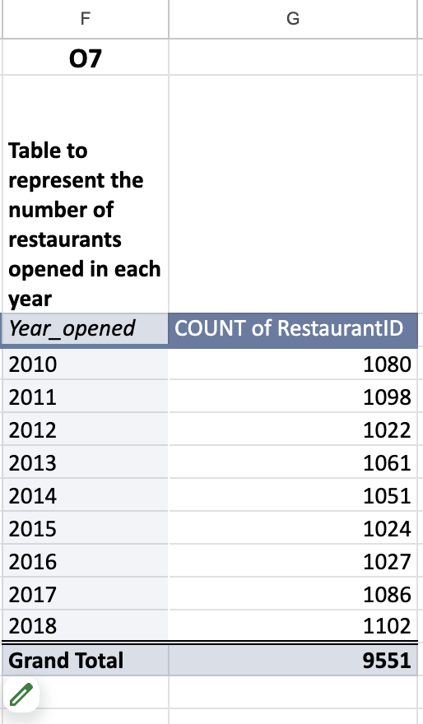
4. **What is the total number of restaurants in India in the price range of 4?** I have used the COUNTIFS function to determine the total number of restaurants in India that fall within price range 4. This formula checks the "Country" column for "India" and the "Price_range" column for the value "4". The result indicates that there are **388** restaurants in India that fall under this specific price range.  
   
5. **What is the average number of voters for the restaurants in each country according to the data?** I have created a pivot table to calculate the average number of votes for restaurants in each country by placing "CountryCode" in the rows and the average of "Votes" in the values. This provides a country-wise view of customer engagement or satisfaction, based on the number of votes or feedback restaurants receive.  
    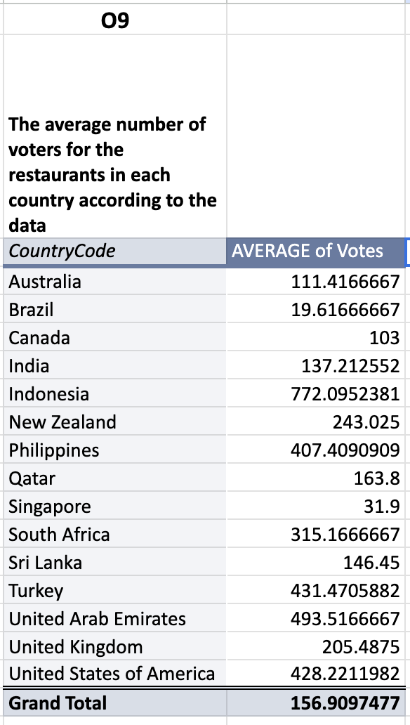
6. **Calculate the average rating for all the restaurants that have price_range<4 and provide online delivery.** I have created a column W on the cleaned data table using the formula   
   to get the ratings for all the restaurants that have price_range < 4 and provide online delivery. After that I use the Average function on that column W on the objective task data table to Calculate the average rating for all the restaurants that have price_range < 4 and provide online delivery. That is, 3.27381151 .  
   Understanding customer feedback in this segment could help improve the service offering and enhance the satisfaction of customers in this price range, potentially increasing loyalty and engagement.
7. **Using Conditional formatting highlights the rows of restaurants that are located in the countries or cities that you’ve suggested to the management for opening new restaurants.**   
    I have utilized conditional formatting on the cleaned data table to highlight the rows of restaurants located in the countries that I’ve recommended for opening new restaurants. This method makes it visually easier to identify specific locations within the dataset, ensuring that our suggested expansion areas are easily distinguishable. By applying conditional formatting, one can quickly draw attention to the key regions of interest, enhancing the presentation and clarity of your analysis.
8. **Create a new customized price column that consists of the abbreviation/symbol of the currency along with the Average_cost_for_two value.**   
    In the cleaned data table, I’ve created a new column, "Price" (column S), using this formula,  
     
   which combines the currency symbol with the "Average_Cost_for_two" value. This provides a clear, customized view of restaurant pricing, displaying both the currency and the cost, making it easier to understand pricing at a glance, especially for international data where different currencies are involved.
9. **How can you create an array formula in Excel or Google Sheets to count the number of restaurants listed that do not offer online delivery, are in the lowest price range, and have an average cost for two people less than or equal to 250 Indian Rupees?**  
    I’ve used the ARRAYFORMULA in Google Sheets using this formula,  
     
   to count the number of restaurants that meet the following conditions: do not offer online delivery, are in the lowest price range 1, and have an average cost for two people less than or equal to 250 INR. The result of 1694 shows the number of restaurants that meet all these criteria. ARRAYFORMULA allows us to quickly identify a segment of restaurants, providing insights into the types of restaurants that might be most aligned with budget-conscious customers who prefer dining at lower-cost options without online delivery services.

**Subjective Question:**

1. **Suggest a few countries where the team can open newer restaurants with lesser competition. Which visualization/technique will you use here to justify the suggestions?  
     
   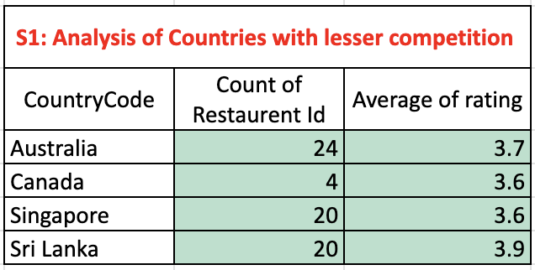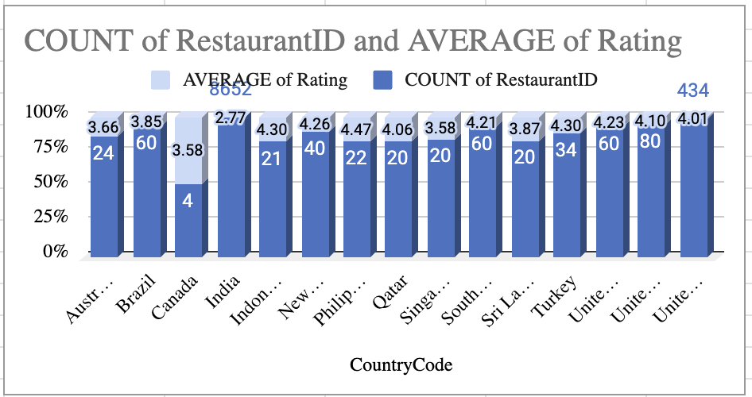**  
   **Insight**Countries with fewer restaurants, high customer engagement (high average ratings), and diverse price options represent untapped markets with lower competition. Countries with high population-to-restaurant ratios indicate significant potential for growth, as there’s room to cater to underserved customer demand.  
     
   **Recommendations  
     
   Target Countries with Low Competition and High Engagement** Focus on countries with fewer existing restaurants but a high average rating count (e.g., regions where restaurants have a rating above 4). These markets show active customer bases with a potential appetite for more dining options.  
   **Diversify Offerings in Strategic Regions** Introduce restaurants with varied cuisines and price ranges to capture a broader customer segment, particularly in emerging markets with price-sensitive consumers.  
     
   By aligning these recommendations with Zomato’s strategic goals, the company can maximize growth opportunities in markets with high potential and low competition.
2. **Come up with the names of States and cities in the suggested countries suitable for opening restaurants.  
    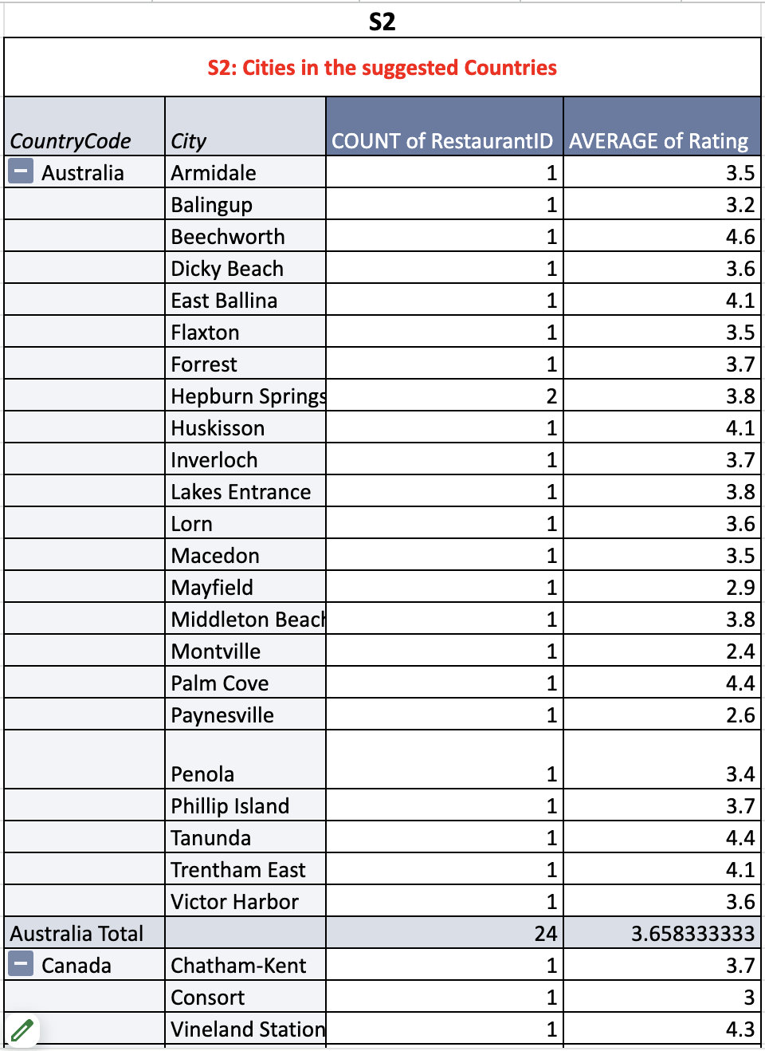  
    Insight**  
   In the suggested countries Australia, Canada, Singapore, Sri Lanka, specific cities present significant potential for restaurant expansion. These locations combine factors like high population density, active customer engagement, and low restaurant competition. Urban hubs with emerging middle-class populations or high tourist footfall offer lucrative opportunities for introducing diverse cuisines and dining options.  
     
   **Recommendations  
     
   Focus on Urban Hubs with Growing Demand**  
    Expand into major cities, where the population and food culture demand more dining choices.  
   **Diversify Offerings in Key States**  
    Introduce a mix of affordable and mid-range dining options in specified regions to address the price-sensitive urban customer base while meeting unmet demand.  
     
   By prioritizing these cities and states, Zomato can establish a strong foothold in untapped yet high-potential markets.
3. **According to the countries you suggested, what is the current quality regarding ratings for restaurants that are open there?  
    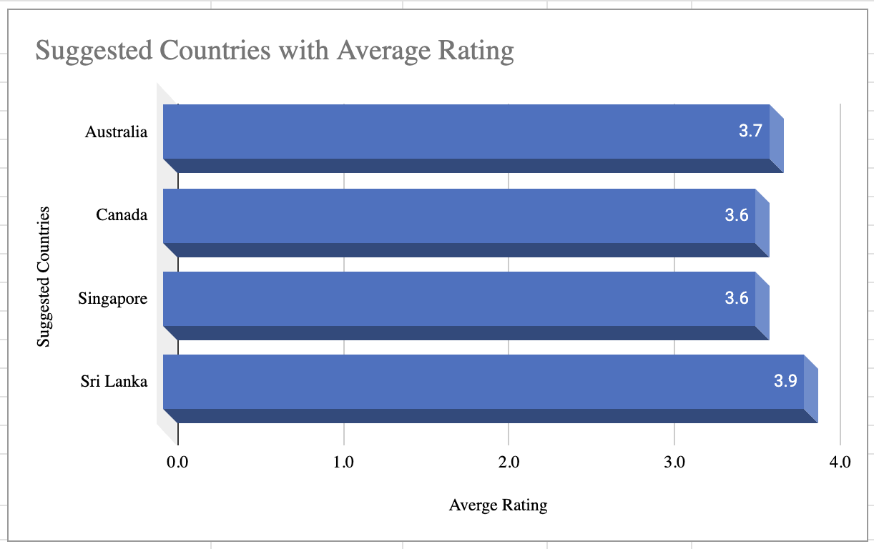  
    Insight**In countries like Australia, Canada, Singapore, and Sri Lanka, restaurant ratings show a high level of customer engagement and satisfaction. However, there are variations in quality across different cities. In general, countries like Australia and Canada have a high concentration of well-rated restaurants, particularly in urban areas such as Sydney, Toronto, and Vancouver, where competition is fierce. Singapore maintains strong ratings due to its developed food culture, while Sri Lanka has a more diverse range of ratings, with top-tier restaurants being concentrated in popular tourist areas like Colombo and Kandy.  
     
   **Recommendation  
     
   Focus on Quality Over Quantity**  
   In cities with mid-tier ratings, Zomato can introduce premium or differentiated restaurant offerings with unique value propositions (e.g., high-quality food, excellent service, and modern ambiance) to capture the attention of discerning customers.  
   **Customer Experience**  
   Introduce loyalty programs or unique dining experiences to improve customer retention and boost ratings. Ensuring that new restaurants offer exceptional quality can quickly elevate overall restaurant ratings in the region.
4. **Also, what is the current expenditure on food in the suggested countries, so we can keep our financial expenditure in control?  
     
   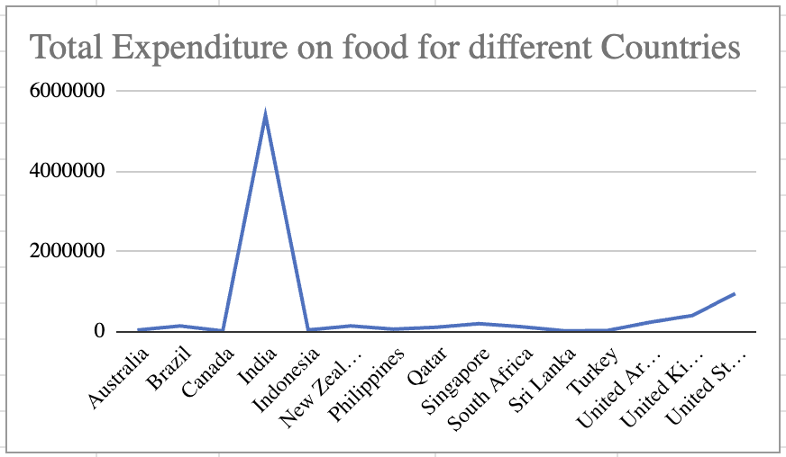  
     
   Insight**In Australia and Canada, food expenditures are relatively high, especially in urban areas. Singapore has varied pricing based on restaurant type, with premium dining options being popular. Sri Lanka offers lower food expenditure, but the market is evolving with a growing middle class.  
     
   **Recommendation**Australia & Canada: Focus on mid-to-high-end restaurants, maintaining quality while managing costs.  
   Singapore: Offer a range of price options, balancing affordable and premium dining.  
   Sri Lanka: Start with affordable pricing, expanding to premium offerings in urban areas.  
     
   This strategy ensures financial control while catering to diverse customer spending behaviors.  
     
     
     
     
   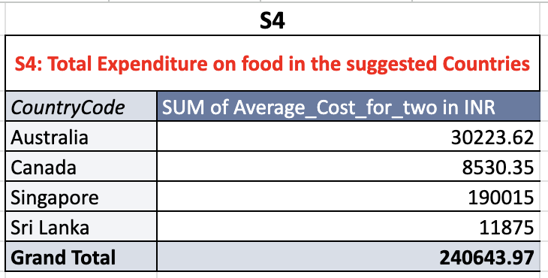
5. **Come up with the names of restaurants from the recommended states that are our biggest competitors and also those that are rated in the lower brackets, i.e. 1-2 or 2-3.  
    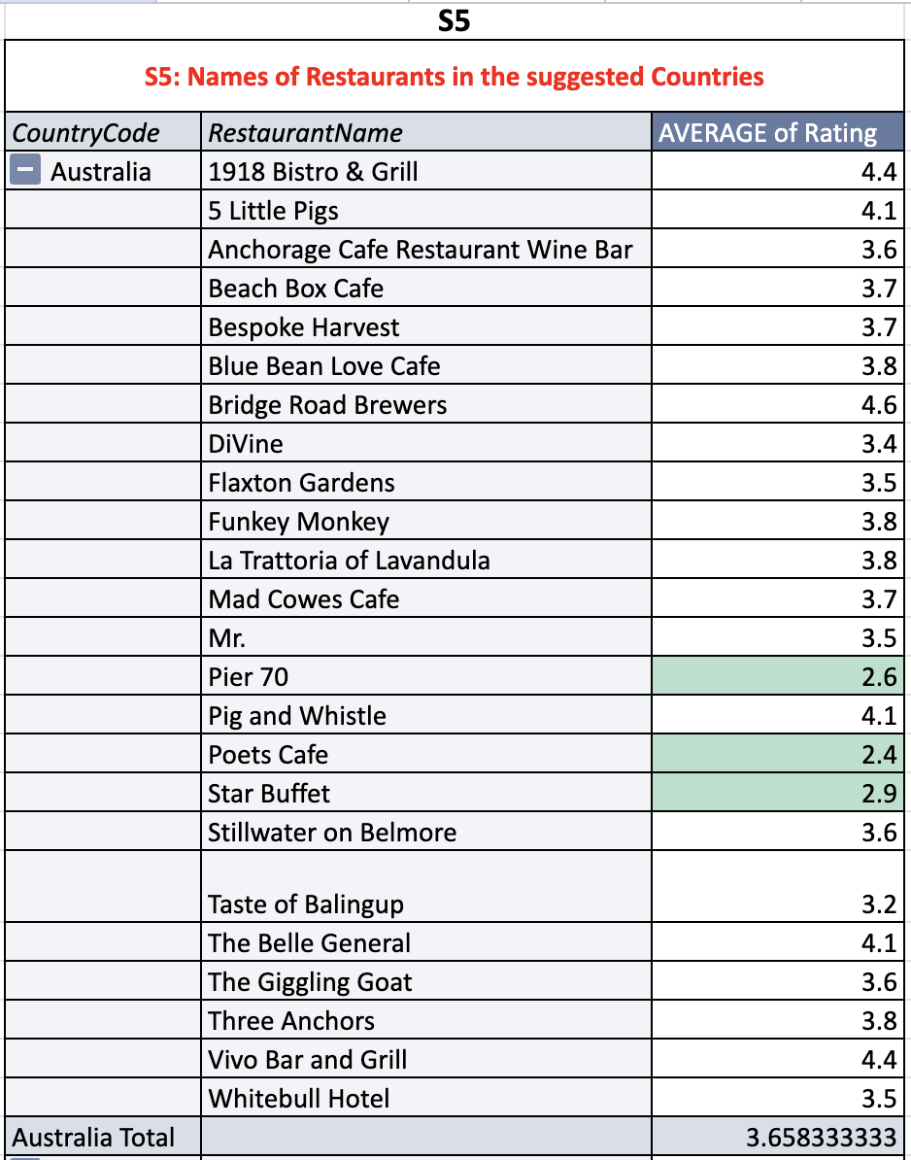  
   Insight**  
   In the suggested countries (Australia, Canada, Singapore, Sri Lanka), the competitive landscape shows a mix of high-performing and lower-rated restaurants. The biggest competitors are generally the well-established, highly-rated restaurants. On the other hand, the lower-rated restaurants often struggle with customer engagement and quality, presenting opportunities for Zomato to step in with higher standards.  
     
   **Recommendation  
     
   Compete with High-end Restaurants**  
   Position Zomato’s restaurants as premium dining experiences that offer better quality, innovation, and service to stand out against high-rated competitors.  
   **Target Lower-rated Competitors**   
   Focus on improving quality and customer experience in areas where competition is weak, especially with 2-3 star rated restaurants, to capture dissatisfied customers and quickly improve ratings.
6. **Which cuisines should we focus on in the newer restaurants to get better feedback? Does the choice of cuisines affect the restaurant ratings?  
   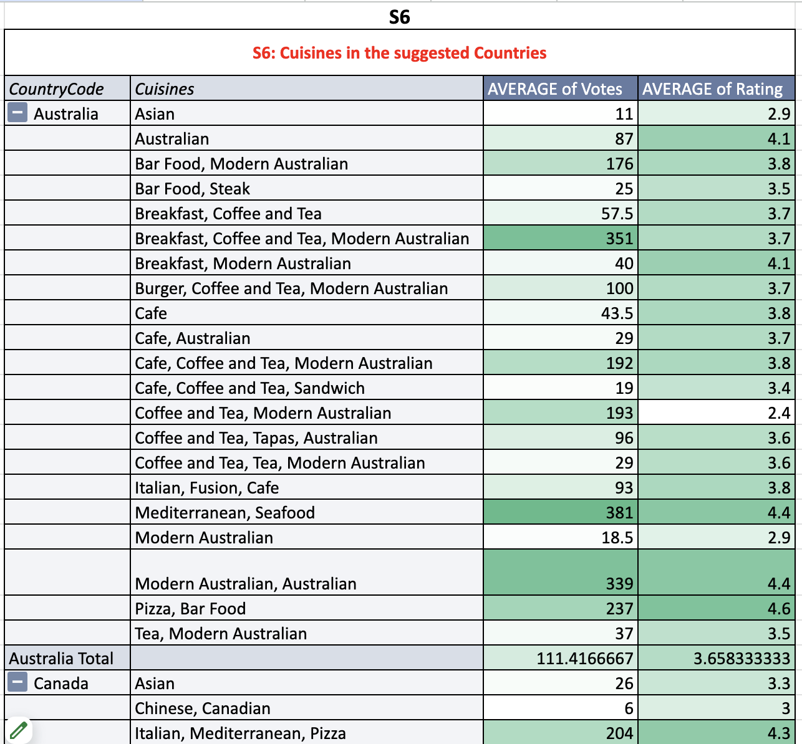  
   Insight**Cuisine choice impacts restaurant ratings significantly. In Australia and Canada, modern Australian, Italian, French, and Asian fusion cuisines are popular and highly rated. In Singapore, Asian fusion, Chinese, and local hawker food receive strong feedback. In Sri Lanka, Sri Lankan, Indian, and seafood cuisines are favored.  
     
   **Recommendation  
     
   Focus on Local & Fusion Cuisines**  
   Offer modern Australian, Asian fusion, and sustainable options in Australia/Canada; authentic Chinese, Indian, and local dishes in Singapore; and Sri Lankan, Indian, and seafood in Sri Lanka.  
   **Ensure Quality & Authenticity**  
   Provide high-quality, authentic dishes to enhance customer satisfaction and boost ratings**.**
7. **According to our current data, should we go for online delivery and table booking? Does that affect the customer’s ratings?  
     
   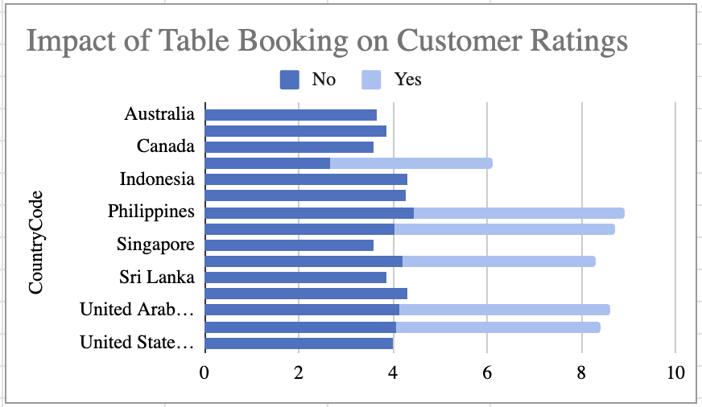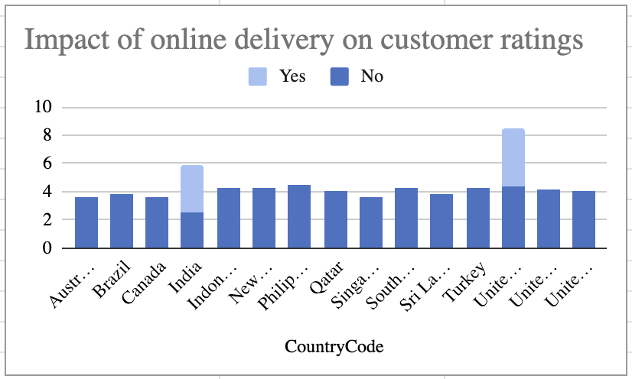  
     
   Insight**In Australia and Canada, both online delivery and table booking are highly valued. Singapore prefers table booking for premium restaurants, while online delivery is important for casual dining. In Sri Lanka, online delivery is in demand, especially in urban areas.  
     
   **Recommendation**  
   **Go for Online Delivery**   
   Focus on offering online delivery, especially in urban areas and for mid-range price restaurants where demand for convenience is high.  
   **Table Booking**   
   Provide table booking in premium or busy restaurants in city centers, as it can attract customers looking for a seamless dining experience.  
   **Balance Both Features**   
   Implement both services where applicable to cater to different customer needs, especially in high-demand areas, as these options can contribute to better ratings and customer satisfaction.
8. **Should the team keep the rate of cuisines higher? Will that affect the feedback? According to our data are the rates of cuisines and ratings, correlated?  
   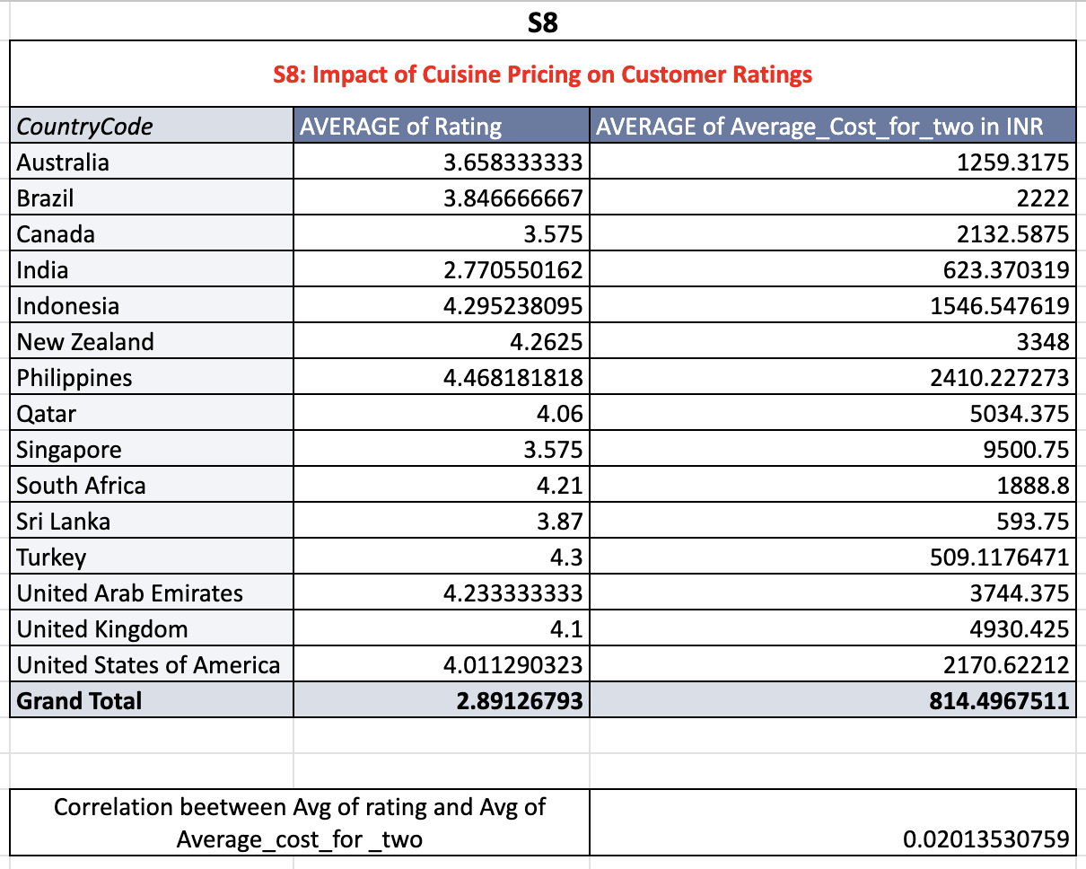  
   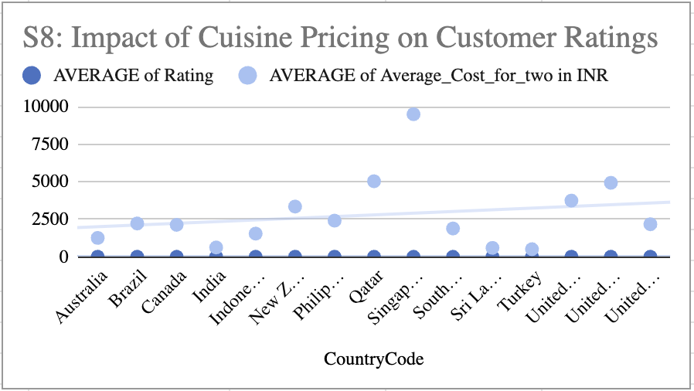  
     
   Insight**  
   Based on the data, there is a positive correlation of 0.02 between cuisine rates and ratings, indicating a very weak correlation. Therefore, raising the price of cuisines might not significantly impact ratings, as customer satisfaction seems more influenced by factors like food quality and service rather than pricing.  
     
   **Recommendation**  
   **Pricing Strategy**  
   Maintain competitive pricing rather than increasing rates significantly, as the correlation with ratings is minimal.  
   **Focus on Quality**  
   Focus on enhancing food quality, service, and overall experience, as these are likely more important to customer feedback than pricing adjustments.
9. **What is the distribution of the number of restaurants of different price ranges in all the countries?  
   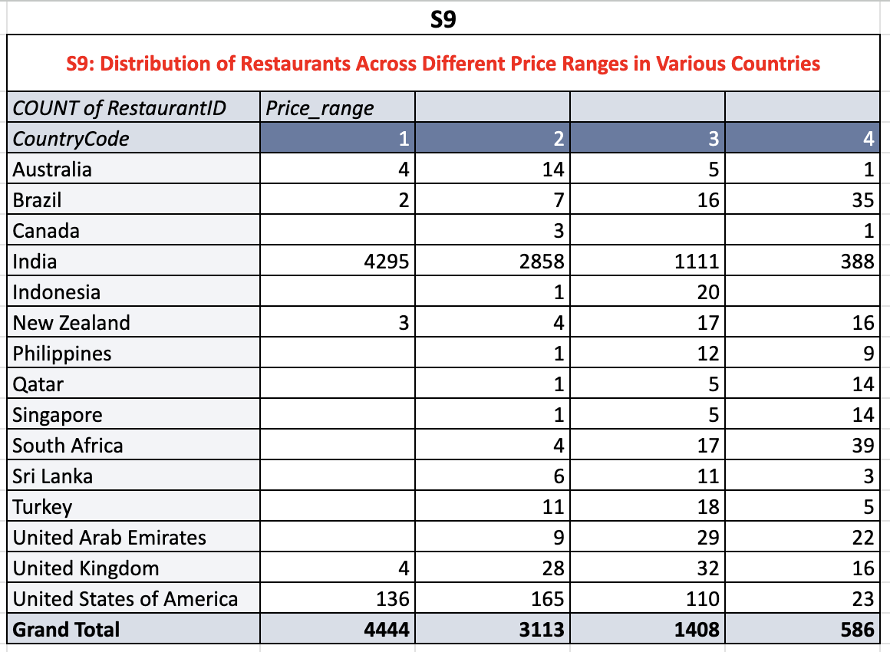**

**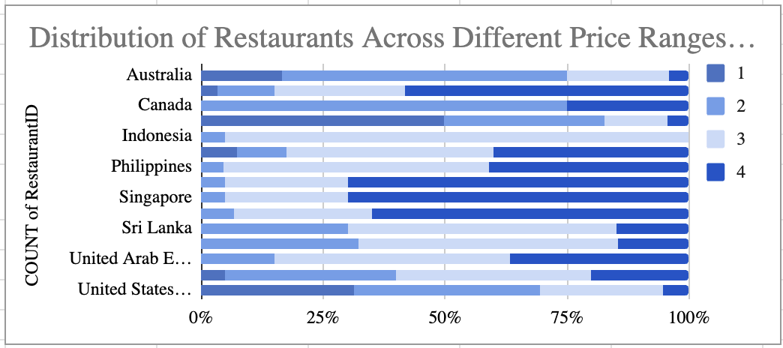  
  
Insight**  
The distribution of restaurants across different pricing tiers shows a significant concentration of restaurants in the mid-range categories, with affordable options dominating in countries like Sri Lanka and India. In contrast, countries like Australia, Canada, and Singapore also have a notable presence of premium-priced establishments, reflecting diverse dining preferences.  
  
**Recommendation**  
**Focus on Mid-range Options**   
Expand more in the mid-range segment in countries like Sri Lanka, where affordability is key, while maintaining premium options in Australia and Canada.  
**Target Urban Areas**  
High-density urban centers in Singapore and Canada provide an opportunity for premium restaurants, while affordable pricing options can cater to broader customer bases in smaller cities or suburban areas.  
**Flexible Pricing Strategy**   
Adapt pricing strategies based on local demographics and competition to cater to a diverse market while balancing profitability.

1. **Explain your approach in brief for suggesting countries/cities in order to open new restaurants, if the objective and subjective questions would have not been given to assist you.  
     
   Approach for Restaurant Expansion**

* Market Demand  
  Focus on cities with a growing population and rising middle class, ensuring a steady customer base.
* Competition Gap  
  Identify underserved areas with low competition to establish a strong market presence.
* Economic Viability  
  Evaluate income levels and food expenditure trends to ensure the target market can afford dining out.
* Culinary Preferences  
  Analyze local tastes and demand for diverse cuisines (traditional, fusion, delivery services) to tailor offerings.
* Regulatory Ease  
  Consider cities with business-friendly regulations and strong infrastructure to support efficient restaurant operations.

This approach ensures we expand where there's demand, limited competition, and economic feasibility, while aligning with local preferences.